Jour. PAS, Vol. 22, pp 34 – 39, 2016 ISSN 0972 – 3498
A Theoretical Study of Phonon Properties
of Dysprosium Monopnictides (DyP)
Md. Imran Aziz
Department of Physics, Shibli National P.G. College, Azamgarh – 276001
e-mail : aziz_muhd33@yahoo.co.in
(Received on 20.06.2016)
Abstract : Many body interactions, which includes the effect of van der Waals interactions (vWI) and three body interactions in the framework of rigid shell model (RSM), has been employed to study the phonon dispersion curve, of the Dysprosium monopnictides (DyP). We assume that the overlap repulsion is effective only up to the ﬁrst neighbour, while the van der Waals attraction acts up to the second neighbours and plays very important role. Because of f-d hybridization, the large LO-TO phonon splitting at zone centre predicted. The agreement between our predictions and available neutron data for phonon dispersion curves strongly supports the inclusion of van der Waals interactions. We also report the speciﬁc heat variations of Dysprosium monopnictides (DyP).
Introduction : The study of phonon vibrational properties of Dysprosium monopnictides DyX (X=P, As) is very interesting, crystallizing into rock-salt structure Dysprosium monopnictides (DyP) has a Fm3m,face-centered cubic with lattice parameter a_{o} = 5.859A⁰ and orders ferromagnetically. Although several theoretical models have been used to predict the phonon dispersion curves (PDCs) of these solids but only with moderate success. After introducing anharmonic vibration in the many-body interactions, we expect that a composite model taking both the effects into account will improve the discrepancies between theory and neutron data. The phonon dynamics of Dysprosium monopnictides (DyP) was studied by various theoretical workers with successively improved models^{[1, 2, 5]}. Although this approach is better than other but without including van der Waals interactions the complete vibrational properties can not be investigated. In order to explain the lattice vibrational behavior of Dysprosium monopnictides (DyP) better, we have employed a model which includes van der Waals interactions and three body interactions and short-range repulsion effective up to the second neighbors in the frame work of rigid shell model. The parameters of this model have been calculated by using measured values of interionic distance (r₀), elastic constants (C₁₁, C₁₂, C₄₄), electronic polarizabilities (α₁, α₂) and frequencies along Γ, X, M and R symmetry directions. These model parameters have been used to compute the phonon spectra for the allowed 48-non equivalent wave vectors in the first Brillouin zone of NaCl structure.
Lattice Dynamical Model : The shell model can be incorporated into the formalism of the dynamical matrix by writing separate equations of motion for the core and the shell. Because the mass of the shell is zero in the shell model, there is no separate mw² for the shell. Instead, the shell instantaneously relaxes to its equilibrium position so that there is no restoring force on the shell. Thus the displacement of the shell is completely tied to the displacement of the cores, and therefore there is not a separate solution for the shell. The contributions of the shells fold into an expanded dynamical matrix for the ionic cores and giving the same number of solutions as for models without ionic shells. There has been always a continuing effort to obtain accurate interatomic potential functions. The interaction potential energy function is generally used to study the crystalline properties of diatomic crystal. The total potential for the Dysprosium monopnictides (DyP) can be written as
Φ = Φ^{C}+Φ^{R}+Φ^{TBI}+Φ^{VWI} (1)
When first term Φ^{C} is coulomb interaction potential and is long-range in nature, second term is Φ^{R} short –range overlap repulsion potential, third termΦ^{TBI} is three-body interactions potential and the last term is Φ^{VWI} van der Waals interactions potential and owes its origin to the correlations of the electron motions in different atoms. We consider that van der Waals energy converges fast but the overlap repulsion converges much faster. Therefore, the overlap repulsion is effective only up to the first neighbor and the van der Waals attraction up to the second neighbors^{[4, 6]}.
Using the crystal potential expression (1) the equations of motion of two cores and two shells can be written as
ω²M U = (R + Z_{m} C' Z_{m}) U + (T + Z_{m} C' Y_{m}) W (2)
O = (T^{T} + Y_{m} C' Z_{m}) U + (S + K + Y_{m} C' Y_{m}) W (3)
Here U and W are vectors describing the ionic displacements and deformations, respectively. Z_{m} and Y_{m} are diagonal matrices of modified ionic charges and shell charges, respectively. The elements of matrix Z_{m} consists of the parameter Z_{m} giving the modified ionic charge
Z_{m} = Zξ = ± Z√1+ (n/Z)f₀. (4)
This means that the ionic charge parameter (Z) of rigid shell model gets modified by a factor {1+(12/Z)f₀} for NaCl – structure.
The elimination of W from equations (2) and (3) leads to the secular determinant:
(5)
Here D (q) is the (6×6) dynamical matrix given by
. (6)
The dynamical matrix, given by equation (5), is a matrix (6×6) leading to six vibrational frequencies (ω_{j}) corresponding each phonon wave vector. For wave-vector along the principal symmetry directions (Γ, Χ, L, Δ) for NaCl in the Brillouin zone can be reduced to lower order (2×2) matrices which simplifies the computational work in solving the characteristic equation (6) and also the number of distinct branches of the dispersion relations get reduced because of the degeneracy.
Results and Discussion :

1. Phonon Dispersion Curves for Dysprosium monopnictides (DyP) –
The phonon dispersion relations have been computed by solving the secular equation for the six vibration frequencies corresponding to the phonon wave vectors (q) along the principal symmetry direction [q00], [00q] and [qqq]. The phonon dispersion curves (Figure – 1) have been obtained by plotting these vibration frequencies (ν) against the wave vector (q) and following points are inferred from the careful analysis of phonon dispersion curves Dysprosium monopnictides (DyP). The dispersion of the longitudinal phonon exhibits oscillatory behavior extending to the large wave vector transfer region. In contrast, the ν -q curves for transverse phonons the oscillatory behavior seems quite insignificant for higher q value. This indicates that the transverse phonons undergo large thermal modulation than do the longitudinal phonon, due to the anharmionicity of atomic vibration at room temperature. The ν -q curves for transverse phonons attain maxima at a higher q value that the longitudinal phonon curves. Three body interactions have influenced LO and TO branches much more than the acoustic branches LA and TA in these halides. The main feature to note is that there is not a separation of optic and acoustic mode frequencies across the range of wave vectors; this is because of association of optical vibrations with electric moments. The transverse modes do indeed show a separation of the optic and acoustic modes but there is not a separation of LO and LA modes. Optical vibrations are important chiefly in the , Dysprosium monopnictides (DyP) owing to the strong electric moments associated with motion. Lattice vibrations with wave vector [q00] are showing LO modes have cations and anions moving in opposite directions parallel to [q00], and the TO modes have the cations and anions moving in opposite directions perpendicular to [q00]. At [000], the both types of motion become exactly equivalent, in this case LO and TO frequencies would be equal. But as shifting from [000] to [q00] ,the long-wavelength optic modes generate electric fields that are either parallel or perpendicular to the direction of propagation of the optic mode will have a significant effect on the frequency of the mode. It follows that ν _{LO} > ν _{TO}. This effect is known as LO/ TO splitting, reflecting the fact at exactly zero wave vector the frequencies are the same.
Table – 1 : Frequencies (TH_{Z}) of DyP
Reference Point | Assignments Values
Γ-Point | LO | 10.97
 | TO | 5.94
 | LO | 8.78
X-point | TA | 6.64
 | LA | 4.61
 | TA | 2.67
L-Piont | LO | 9.59
 | TO | 5.67
 | LA | 5.09
 | TA | 3.03

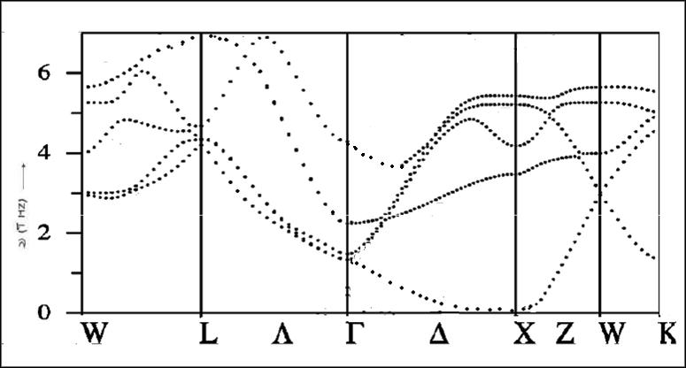
Figure – 1 : Phonon dispersion curves of Dysprosium monopnictides (DyP)
2. Debye temperatures variation –
The variation of the experimentally measured specific heats is compared with that computed from the phonon spectra. This comparison is usually done by plotting the Debye temperatures against the temperature. For calculating the exact variation of Debye temperatures we have used the Blackmann's^{[3]} sampling technique. In this technique, the frequency spectrum is divided into a suitable number of equal intervals and the specific heat is expressed as a sum over Einstein functions corresponding to the mid point of each interval. Thus,
(7)
where E (v) is the Einstein function, ℜ is the gas constant and g(v)dv are the number of frequencies lying in the interval (v-dv/2) to (v+dv/2). From the calculated specific heats at different temperatures. Θ_{D} is calculated by means of standard tables. Thus (Θ_{D}-T) curve is plotted (Figure – 2) and compared with the available experimental data. The specific heat at constant volume behavior of the Dysprosium monopnictides (DyP) does not show any anomaly.

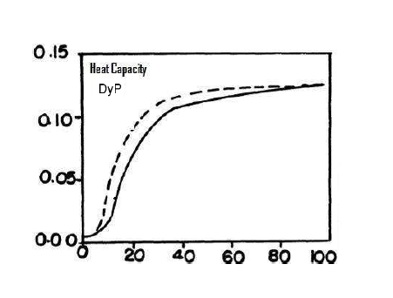
Figure – 2 : Lattice specific heat of Dysprosium monopnictides (DyP)
References :
- Arya, B. S.; Aynyas, M. and Sanyal, S. P. (2008) : Proceedings of 53rd Solid State Physics Symposium.
- Arya, B. S.; Aynyas, M. and Sanyal, S. P. (2009) : Journal of Nuclear Materials, Volume 393, Issue 3, p 381.
- Blackmann, M. (1955) : Trans. Roy. Soc., A 236, p 102.
- Imran Aziz M.; Irfan Ahmed and Ahmed Naeem (2008) : International Journal of Chemical Sciences, Vol. 6, p 1415.
- Jha, P. K.; Sanyal, S. P. and Singh, R. K. (2002) : PINSA, 68, A, No.1, p 57.
- Singh, R. K. (1982) : Physics Reports (Netherlands), 85, p 259.
- Smart, C.; Wilkinson, G. R.; Karo, A. M. and Hardy, J. R. (1965) : Lattice Dynamics, Edited by R. F. Wallis (Pergamon Press, Oxford).
* * *

